Open Schooling, Dressage and Combined Test schooling show
New USEA Dressage test

See willowdraw.com for link to NEW tests

USEA Combined Test $35. Starts at 8:30 am on Sunday

Dressage Show $18 per class. Starts after USEA tests completed

Dressage judge: Clare Morrow “L”

Closing date is January 13th

www.willowdraw.com

Open Schooling Saturday, January 16th
Schooling Shows, Combined Test and Dressage only
Sunday January 17th

CLOSING DATE: January 13th – really!!

MORE INFO:
Janet 817.313.1515
janetbook@hotmail.com

Entry forms and ride times online, www.willowdraw.com
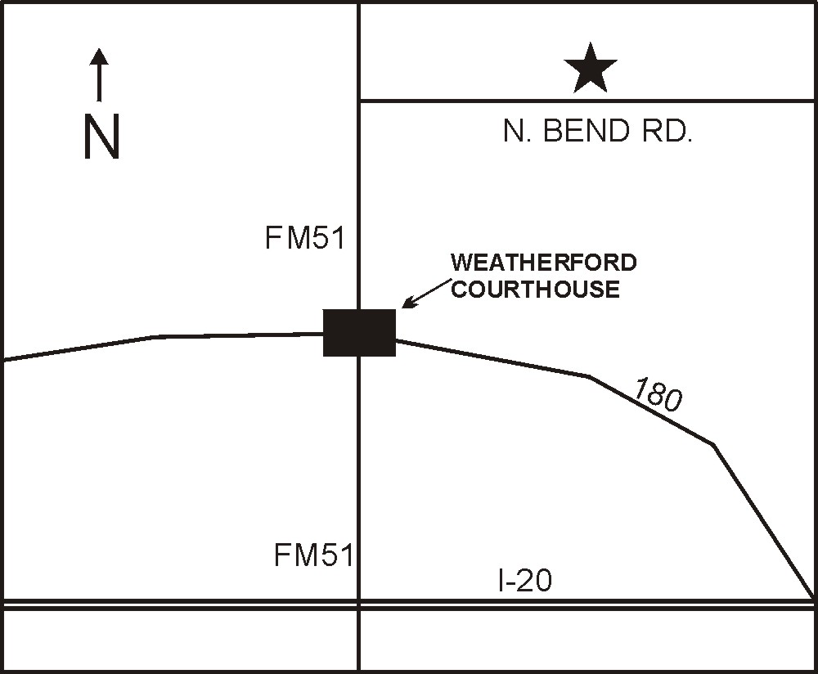
Saturday, January 16th, 9 am to 4 pm, open schooling $35

- New XC jumps and course design by Stuart Black
- 2nd water complex under development
- Covered arena with 20x40 dressage ring
- XC jumps
- Metered galloping lane
- Outdoor show stadium course

Sunday, January 17th, 8:30 am start time. Dressage judge, Clare Morrow “L”

Combined test classes: Elem 18” & Elem 2’0”, Beginner Novice, Novice, Training, Preliminary

USEA 2010 Tests!!! See WillowDraw.com for tests.

Combined test dressage: Elem: USEA BN A, BN: USEA BN A, Nov: USEA Nov A, Training: USEA Training A, Prelim: USEA Prelim A

Entries: Combined test, one ride per class. Ribbons 1st-6th.

Time schedule: Dressage starts at 8:30 am, USEA Elem, BN, Nov, Training, Prelim and USDF in that order.

All riders must wear, at a minimum; ASTM/SEI approved helmets/boots. A negative coggins is required for all horses within the last 12 months.

Dogs discouraged or leased at all times. No exceptions.
 | $35 per schooling combined test class
 | Circle combined test class(s) |  | Subtotal
Class | Elem 18” Elem 2’0” BN Novice Training Prelim
 | $18 per schooling dressage only test class
 | Circle dressage only test class(s)
Class | Intro A Intro B Training 1 2 3 4
Class | Other – Specify:
Cross country schooling: $35
Stabling per day: $20
Total:
Rider Name:
Address:
Rider: Senior □ Junior □
Phone:
Email:
Horse Name:

RIDER / PARENT/ GUARDIAN RELEASE AGREEMENT
Willow Draw – LP, sponsors, facility providers, organizers and beneficiaries are hereinafter referred to as Equine Activity Sponsors. The Equine Activity Sponsors, their officers, members, employees, and agents will not be responsible for any damages to person, animal, or property at the show or in the grounds, nor will they be responsible for any property lost or destroyed. The undersigned rider/parent/guardian hereby releases the Equine Activity Sponsors, their officers, members, employees and agents from any and all liability, claims, and damages whatsoever (including costs, expenses, and attorney’s fees) that might result from damages, injuries, or losses to their person or property during, or in connection with, or arising out of any show, clinic, event, or function, whether or not such damages, injuries, or losses result directly or indirectly from the negligent act or omission of such released parties. WARNING UNDER TEXAS LAW (CHAPTER 87, CIVIL PRACTICE AND REMEDIES CODE), AN EQUINE PROFESSIONAL IS NOT LIABLE FOR AN INJURY TO OR THE DEATH OF A PARTICIPANT IN EQUINE ACTIVITIES RESULTING FROM THE INHERENT RISKS OF EQUINE ACTIVITIES. In exchange for the use of property owned by the Facility Providers and other valuable consideration, I agree that my use of the premises and any animals, facilities, or equipment owned by the Facility Provider is at my own risk. I further agree to indemnify and hold harmless the Equine Activity Sponsors, the Facility Providers, and the Beneficiaries, their officers, members, employees and agents from any and all suits, actions, or claims of any type arising from my use of the premises or the participation in the equine activity or such use by my guest, whether such claims result from the act or omissions of the indemnified parties or otherwise. I acknowledge that riding and involvement with horses is a high-risk activity. I have read this agreement and fully understand its content.

Name: _________________________________DATE: _____________

SIGNATURE OF RIDER/PARENT/GUARDIAN: __________________

Questions - Call: 817.313.1515

Entry form – Sunday, January 17th

1 entry form per horse

Send Entries, Coggins and Fees To:
Willow Draw, LP
573 North Bend Road
Weatherford, Texas 76085
Phone: 817.313.1515

